[](https://www.google.co.in/url?sa=i&url=http://newhorizonindia.edu/nhengineering/wp-content/uploads/2018/02/mba-syllabus-10th-feb-2018-final-1.pdf&psig=AOvVaw0uQhiCLyvplhhU1vbOaxYi&ust=1573707996092000&source=images&cd=vfe&ved=0CAIQjRxqFwoTCNCe9aO15uUCFQAAAAAdAAAAABAJ)

**DEPARTMENT OF ELECTRICAL AND ELECTRONICS**

**MINI PROJECT**

**MOBILE PHONE DETECTOR CIRCUIT**

**GROUP MENTOR**

Mrs. RASHMIN

**SUBMITTED BY:**

KIRAN U (USN: 1NH18EE026)

MANOJ KUMAR M B (USN: 1NH18EE028)

NAVEENKUMAR K R (USN: 1NH18EE035)

**MOBILE PHONE DETECTOR CIRCUIT**

**CERTIFICATE**

This is to certify that Kiran U, Manoj Kumar M B, Naveen Kumar K R, bearing USN: 1NH18EE026, 1NH18EE028, 1NH18EE035 respectively have submitted mini project titled

**“MOBILE PHONE DETECTOR CIRCUIT”**in partial fulfilment for the course of the EEE Department.

This report has been prepared as per the given format and is approved for the submission and presentation.

**Signature of the** guide Signature of the HOD

(Mrs. Rashmi N) (Dr. Ramkumar S)

**ACKNOWLEDGEMENT**

It is indeed a great pleasure to recall the people who have helped me in carrying out this project. Naming all the people who have helped me in achieving this goal would be impossible, yet I attempt to thank a selected few who have helped me in diverse ways.

I wish to excess my sincere gratitude to **Dr. Manjunatha, Principal,** NHCE, Bangalore, for providing me with facilities to carry out this project.

I wish to express my sincere gratitude to **Dr. S Ramkumar, Head of the Department,** Electrical & Electronics Engineering, for his constant encouragement and cooperation.

I wish to express my sincere gratitude to my teacher and guide **Ms. Rashmi .N,** Assistant Professor in the Department of Electrical & Electronics Engineering, NHCE, for her valuable suggestions, guidance, care & attention shown during the planning, conduction stages of this project work.

I express my sincere thanks to project coordinators, all the staff members and non-teaching staff of Department of Electrical & Electronics Engineering, for the kind cooperation extended by them.

I thank my parents for their support and encouragement throughout the course of my studies.

**TABLE OF CONTENTS:**

|  |  |  |
| --- | --- | --- |
| Serial no. | Contents | Page no. |
| 1. | ABSTRACT | 7 |
| 2. | INTRODUCTION | 8 |
| 3. | OBJECTIVE | 9 |
| 4. | COMPONENTS | 10­-13 |
| 5. | WORKING | 14-18 |
| 6. | APPLICATIONS | 19 |
| 7. | LITERATURE SURVEY | 20 |
| 8. | CONCLUSION | 21 |

**LIST OF FIGURES:**

|  |  |
| --- | --- |
| **Fig name** | **Page no.** |
| Fig: a | 11 |
| Fig: b1, Fig: b2 | 12 |
| Fig: c | 13 |
| Fig: d | 14 |
| Fig: e | 15 |
| Fig: f | 17 |
| Fig: g, Fig: h | 19 |

**ABSTRACT**

This handy, pocket-size mobile transmission detector or sniffer can sense the presence of an activated mobile phone from a distance of one and a half meters. So it can be used to prevent use of mobile phones in examination halls, confidential rooms, etc. It is also used for detecting the use of mobile phone for spying and unauthorized video transmission even if the mobile phone is kept in the silent mode. The moment the Bug detects RF transmission signal from an activated mobile phone, it starts sounding a beep alarm and the LED blinks. The alarm continues until the signal transmission ceases.

**KEYWORDS:** OP-AMP[IC CA3130], Timer[IC NE555], Piezo Buzzer.

**INTRODUCTION**

An increase in the technology in the world using the electronics equipment are being used in a wrong way like, in the examination halls and confidential rooms. To avoid this we are introducing a project called **CELLPHONE DETECTOR.**

This handy, pocket-size mobile transmission detector or sniffer can sense the presence of an activated mobile cell phone from a distance of one and a half meters. So it can be used to prevent use of mobile phones in examination halls, confidential rooms, etc. It is also useful for detecting the use of mobile phone spying and unauthorized video transmission. The circuit can detect the incoming and outgoing calls SMS and video transmission signal from an activated mobile phone, it starts sounding a beep alarm and the LED blinks. The alarm continues until the signal transmission ceases.

**OBJECTIVE**

The most common electronic equipment used now-a-days is cell phone or mobile phone with advancement in communication technology. The requirement of cell phones has increased dramatically. A cell phone typically transmits and receives signals in the frequency range of 0.9 to 3GHz. This article provides a simple circuit to detect the presence of an activated cell phone by detecting these signals.

I have designed two circuits that act as cell phone detector circuit, one using a combination of Schottky Diode and a voltage comparator and the other using Bi-CMOS Op-Amp.

**COMPONENTS**

* BC548 BJT Transistor
* Op-Amp CA3130
* Resistor
* Capacitor
* Battery

**BC548 NPN TRANSISTOR:**

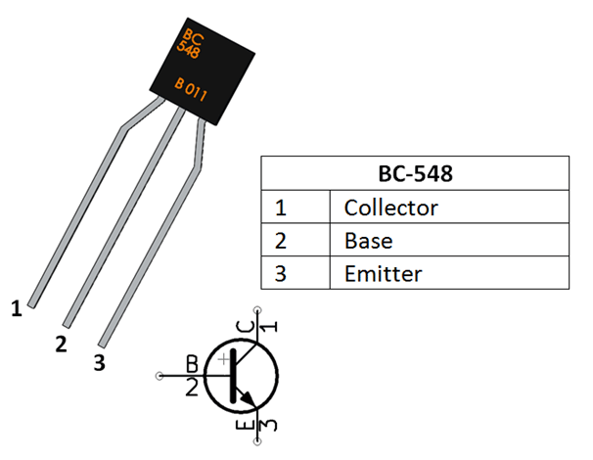

**Fig: a**

BC548 is a NPN transistor so the collector and emitter will be left open (reverse bias) when the base pin is held at ground and will be closed (forward bias) when a signal is provided to base pin. BC548 has a gain value of 110 to 800, this value determines the amplification capacity of the transistor. The maximum amount of current that could flow through the collector pin is 500mA, hence we cannot connect loads that consume more than 500mA using this transistor. To bias a transistor we have to supply current to base pin, this current should be limited to 5mA.

**OP-AMP CA3130:**

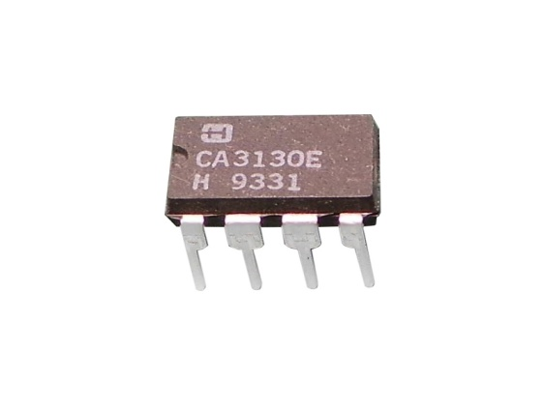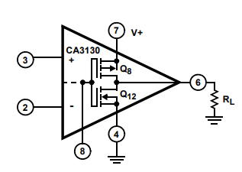

Fig: b(1) Fig: b(2)

CA3130 is the 15MHz Bi-MOS IC with MOSFET inputs and a bipolar output. MOSFET transistors are present in the inputs that provide very high input impedance. It is excellent op amp that requires very low input current requirements. Its output will be in the zero state in the off mode.

The input current can be as low as 10pA. The IC shows very high speed of performance and combines the advantage of both CMOS and bipolar transistors. The presence of PMOS transistors at the inputs results in common mode input voltage capacity down to 0.5 volts below the negative rail. So it is ideal in single supply applications. It also has terminals to adjust the offset voltage.

**RESISTOR**

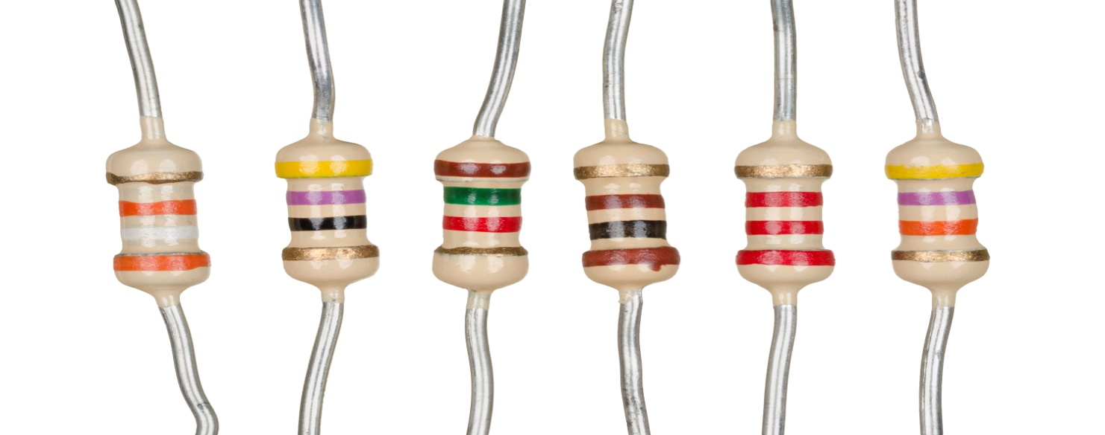

Fig: c

A resistor is a passive two-terminal electrical component that implements electrical resistance as a circuit element. In electronic circuits, resistors are used to reduce current flow, adjust signal levels, to divide voltages, bias active elements, and terminate transmission lines, among other uses.

High-power resistors that can dissipate many watts of electrical power as heat, may be used as part of motor controls, in power distribution systems, or as test loads for generators. Fixed resistors have resistances that can only change slightly with temperature, time or operating voltage. Variable resistors can be used to adjust circuit elements, or as sensing devices for heat, light, humidity, force, or chemical activity.

**WORKING**

The Op-amp part of the circuit acts as the RF Signal Detector while Transistor part of the circuit act as the indicator. The capacitor collection along with antenna are used to detect RF Signals when a cell phone makes (or receives) a phone call or sends (or receives) a text message.

Op-amp reads the signals by converting the rise in current at input to voltage at output and the LED will be activated.

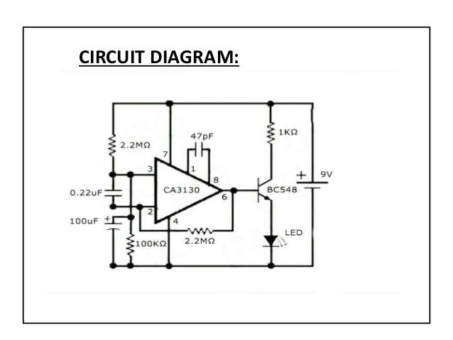

Fig: d

**BASIC PRINCIPLE OF MOBILE PHONE DETECTOR CIRCUIT**

The basic principle behind the Cell Phone Detector circuits is to detect the RF signals. In the Schottky diode circuit, the Schottky Diode is used to detect the cell phone signal as they have a unique property of being able to rectify low frequency signals, with low noise rate.

When an inductor is placed near the RF signal source, it receives the signal through mutual induction. This signal is rectified by the Schottky diode. This low power signal can be amplified and used to power any indicator like an LED in this case.

**DETECTOR CIRCUIT DESIGN:**

The detector circuit consists of an inductor, diode, a capacitor and a resistor. Here an inductor value of 10uH is chosen. A Schottky diode BAT54 is chosen as the detector diode, which can rectify low frequency AC signal. The filter capacitor chosen is a 100nF ceramic capacitor, used to filter out AC ripples. A load resistor f 100 Ohms is used.

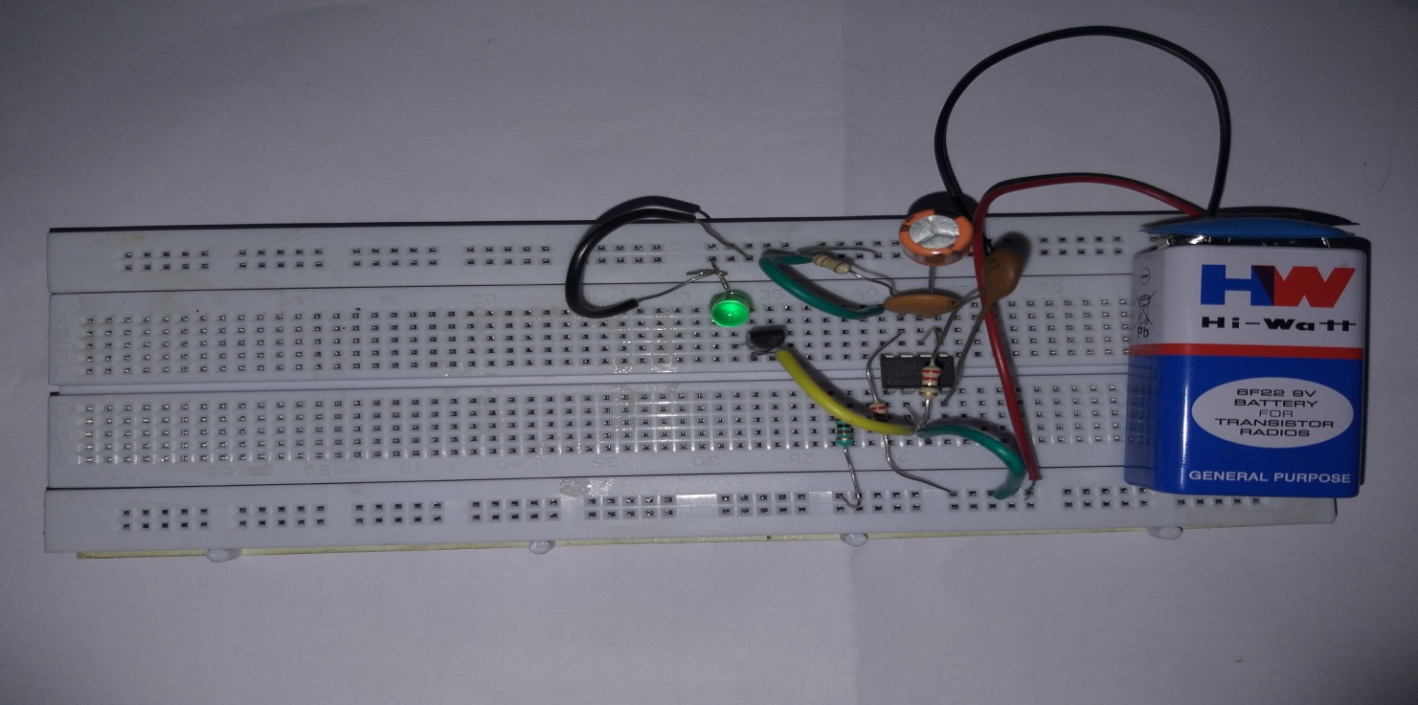

Fig: e

**AMPLIFIER CIRCUIT DESIGN**

Here a simple BJT BC547 is used in common emitter mode. Since the output signal is of low value, the emitter resistor is not required in this case. The collector resistor value is determined by the value of battery voltage, collector emitter voltage and collector current.

Now the battery voltage is chosen to be 12v (since maximum open source collector emitter voltage for BC547 is 45v), operating point collector emitter voltage is 5v and collector current is 2mA. This gives a collector resistor of approx 3K. Thus a 3K resistor is used as RC. The input resistor is used to provide bias to the transistor and should be of larger value, so as to prevent the flow of maximum current. Here we chose a resistor value of 100K.

**MOBILE PHONE TRACKING CIRCUIT OPERATION**

In normal condition, when there is no RF signal, the voltage across the diode will be negligible. Even though this voltage is amplified by the transistor amplifier, yet the output voltage is less than the reference voltage, which is applied to the inverting terminal of the comparator. Since the voltage at non inverting terminal of the OPAMP is less than the voltage at the inverting terminal, the output of the OPAMP is low logic signal.

Now when a mobile phone is present near the signal is demodulated by the diode. This input voltage is amplified by the common emitter transistor. The output voltage is such that it is more than the reference output voltage. The output of the OPAMP is thus a logic high signal and the LED starts glowing, to indicate the presence of a mobile phone. The circuit has to be placed centimeters away from the object to be detected.



Fig: f

**SIGNAL AMPLIFIER USING BJT**

BJT or Bipolar Junction Transistor in its common emitter form is the most common amplifier used. A transistor amplifier works on the fact that the input base current is amplified to the output collector current by a factor of beta. Here the emitter is the common terminal.

The circuit is biased using a voltage divider circuit formed by combination of two resistors. When a transistor is biased in active region, i.e. the emitter base junction is forward biased and the collector base junction is reverse biased, a small base current results in a larger collector current.

**APPLICATIONS**

1. This circuit can be used at examination halls, meetings to detect presence of mobile phones and prevent the use of cell phones.
2. It can be used for detecting mobile phones used for spying and unauthorized transmission of audio and video.
3. It can be used to detect stolen mobile phones.

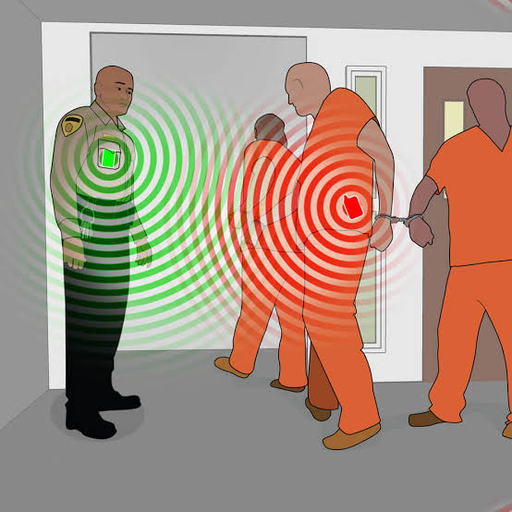

Fig: g



Fig: h

**LITERATURE SURVEY:**

1. “Cell-buster Cell Phone Detector”, Cell-busters INC.2004. Accessed September, 2008. <http://www.cellbusters.com>
2. “Wolfhound Cell-phone Detector”, Berkeley Varitronics Systems. 2010. Accessed March, 2009. <http://www.bysystems.com>
3. “Cell Phone Detection Techniques”, U.S. Department of Energy, October 2007. Accessed January, 2010. <http://inspire.ornl.gov>
4. “Detecting and Locating Cell Phones in Correctional Facilities”, EVI Technology, LLC. June 2007. Accessed February, 2010. <http://iiw.itt.com/files/cellHound_wpCellPhonesInPrison.pdf>
5. “Cell Phone Detector”, Circuit-Projects.com Quality Circuits Archive. Accessed March, 2009. <http://www.circuit-projects.com/rf-radiofrequency-circuit/cell-phone-detector.html>
6. “How Cell Phones Work”, How Stuff Works a Discovery Company. Accessed April, 2009. <http://www.howstuffworks.com/cellphone.htm/printable>

**CONCLUSION:**

We described this pocket size mobile transmission detector or sniffer that senses the presence of activated mobile phones from a distance of one and half meter. So it can be used to prevent the use of mobile phones in examination halls, confidential rooms, etc. It is also useful for detecting the use of mobile phones for spying and unauthorized transmission.